***Web development Project Final Report***

Prepared by: Xiaoting Lian

Date: 12/15/2021

Class: CISC 4900 FALL

Section: VC1A

# The goal for this project is to create a website for House of Nail Spa 1, since they don’t have their website, as a beginner for web development, I have to learn this new skill in order to complete this project. Thanks to Udemy, they provide cheap price for web development course online, the instructor is Colt Steele.

In the proposal I said the site structures are home, about, contact, blog, and new event, but the final work had different structure, because after submitting interim report, I discussed with the business owner, the business owner wants something different. Especially when it comes to blog and booking system, the owner does not read comments or online reviews often, and they already have partnership with Snailz and Classpass, these two appointment systems have two different calendars. The business owner does not want the see third one, it would be too complicated to watch three calendars, and the salon might be overbooking, therefore the booking system and blog was removed.

Since booking system and blog is removed, it makes this project left with only front-end design. As I continue watch the tutorial, it gives tips about how to see other webs elements and their style sheet. I started to think maybe I could make the web look nicer, and I started look all online about how the nail salon should look like.

This is the old look of the web page

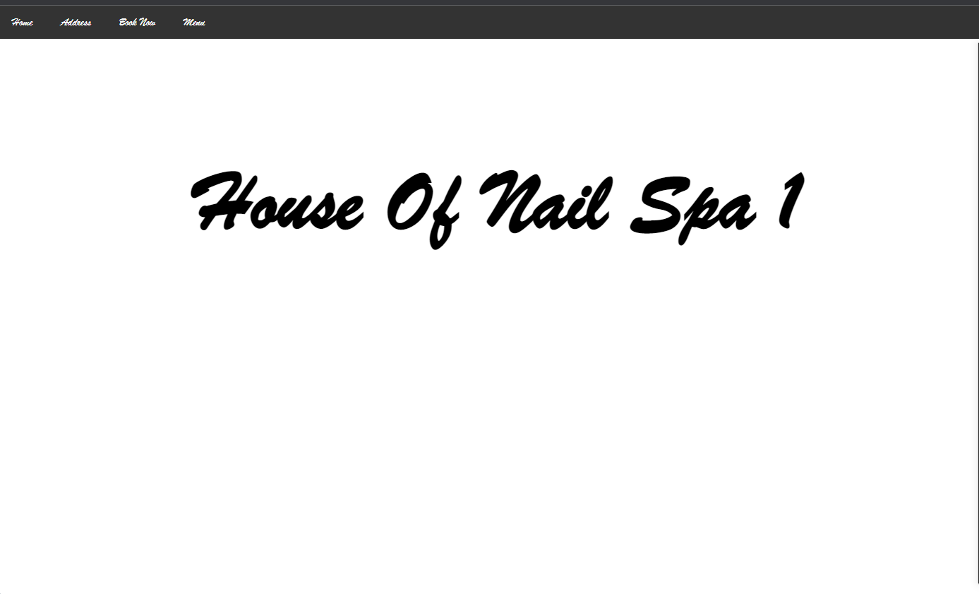

After discussion with business owner, I decide to start all over. Since I already have some experience with the front end. I can do it quickly and show it to business owner.

The difficult part of the project is communicated with business, because you and the business owner have different art sense, like the background color and background image, I have changed over 10 time, and end up with a photo that is in yelp, the tutorial does not tell you everything you need to make your web looks nice, and another difficult part of this project is I have to start over, I was worry about am I going to finish on time. good thing is the tutorial talked about bootstrap and developer.mozilla.org, and stack overflow. these three websites really help me design the web.

This is new look

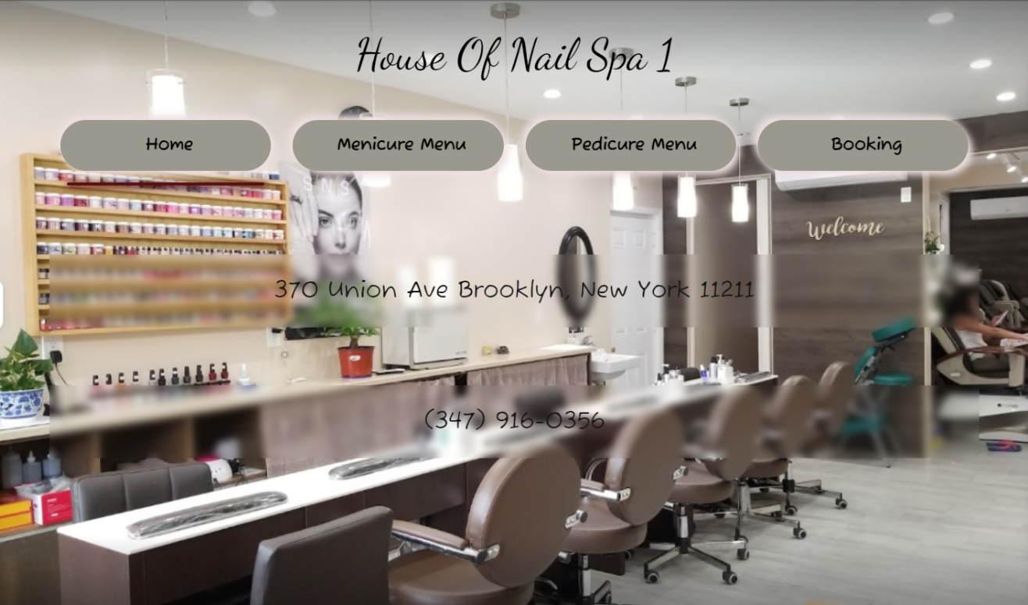

Since I only have the front-end work. The image below shows what I learn from Udemy as proof

. 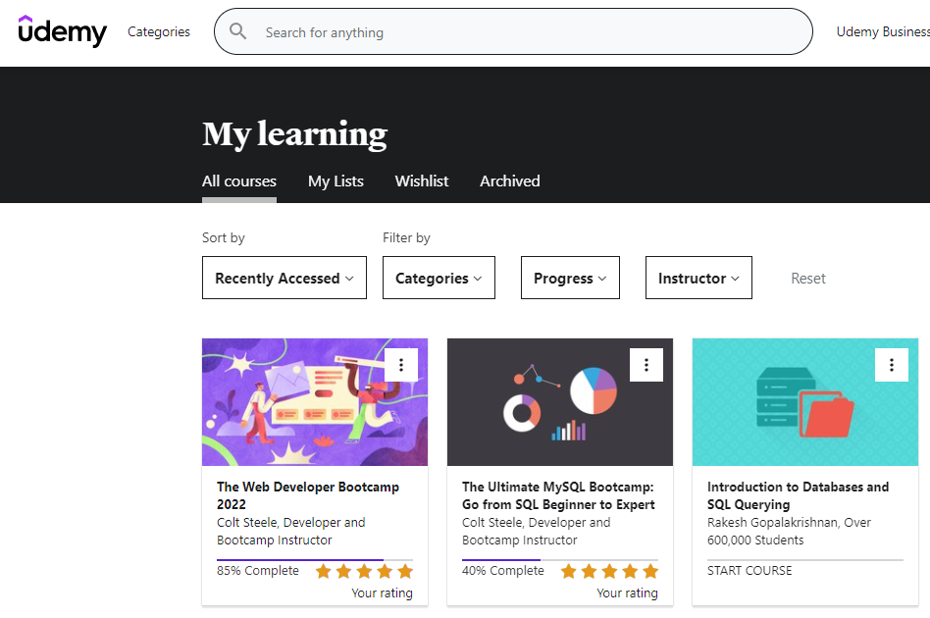

The incomplete part of 15% is some of html and css languages I already know, the note that is provided and some of old version of this course, the course is about 60 hours long.

The course material covers

* **HTML5**
* **CSS3**
* Flexbox
* Responsive Design
* **JavaScript (all 2022 modern syntax, ES6, ES2018, etc.)**
* **Asynchronous JavaScript**- Promises, async/await, etc.
* **AJAX**and single page apps
* Bootstrap 4 and 5 (alpha)
* SemanticUI
* Bulma CSS Framework
* **DOM Manipulation**
* Unix(Command Line) Commands
* **NodeJS**
* NPM
* **ExpressJS**
* Templating
* **REST**
* **SQL** vs. **NoSQL** databases
* **MongoDB**
* Database Associations
* **Schema Design**
* Mongoose
* **Authentication From Scratch**
* Cookies & Sessions
* Authorization
* **Common Security Issues - SQL Injection, XSS, etc.**
* Developer Best Practices
* **Deploying Apps**
* **Cloud Databases**
* **Image Upload**and Storage
* **Maps and Geocoding**